

|  |  |
| --- | --- |
|  | Lab 2: VM using CLI, ARM templates, N-Tier architecture. |
|  |  |
|  | Akshar Panchani ID- 202101522  IT457 Cloud Computing  1/30/24 |

1. Create a VM using CLI: -

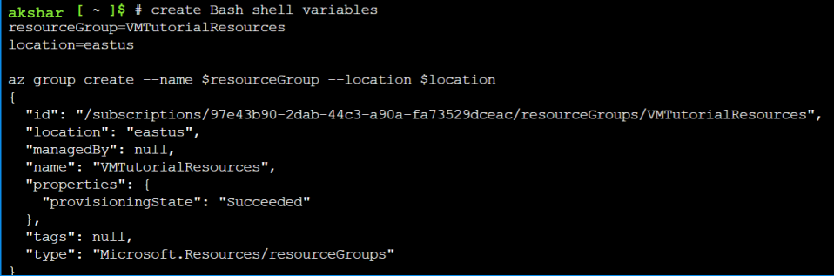

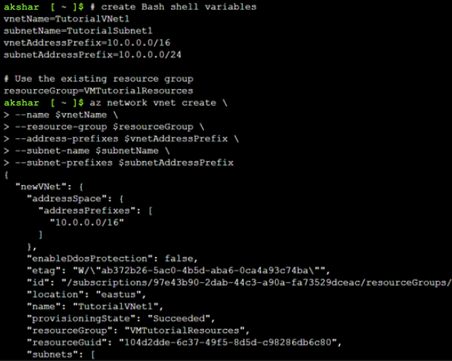

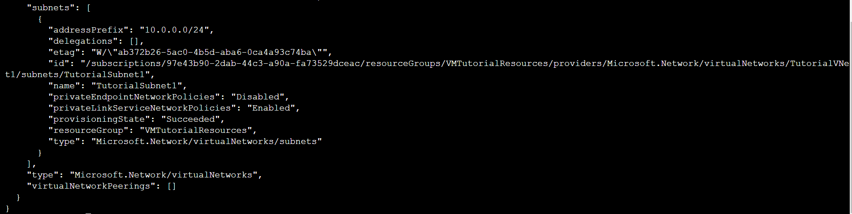

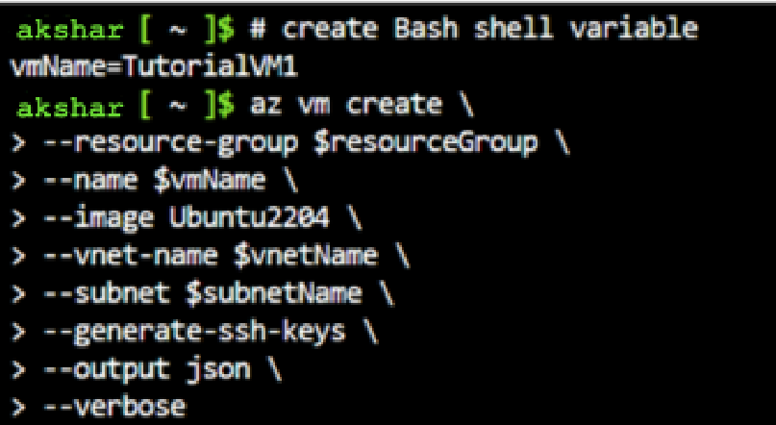

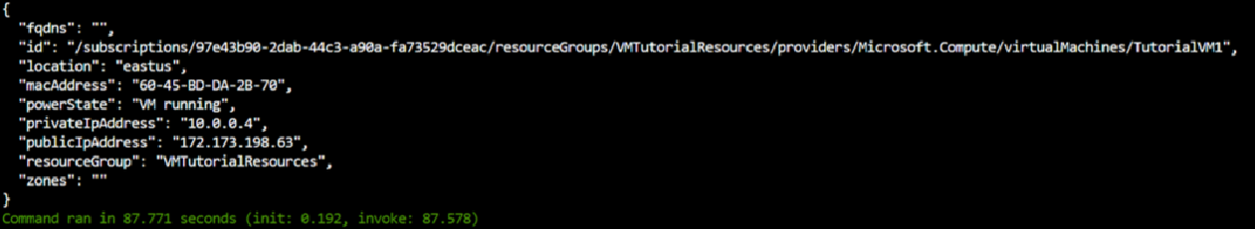

Result:

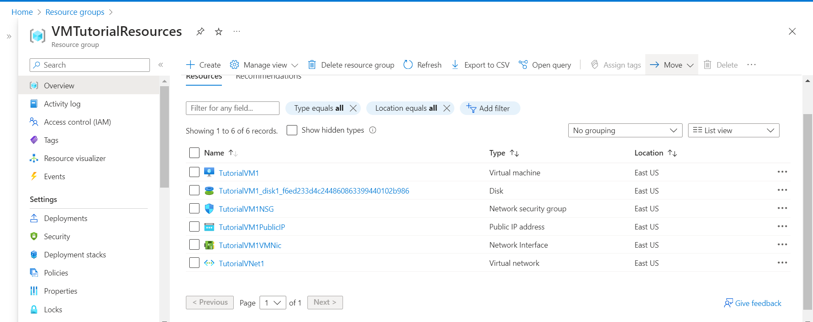

2. Introduction to ARM templates: -

a. Creating first template

JSON:

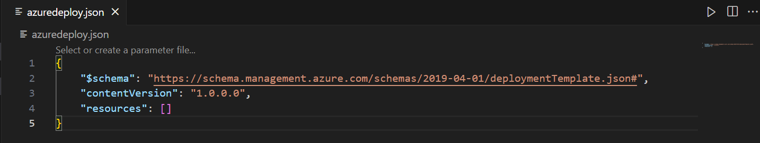

Deployment:

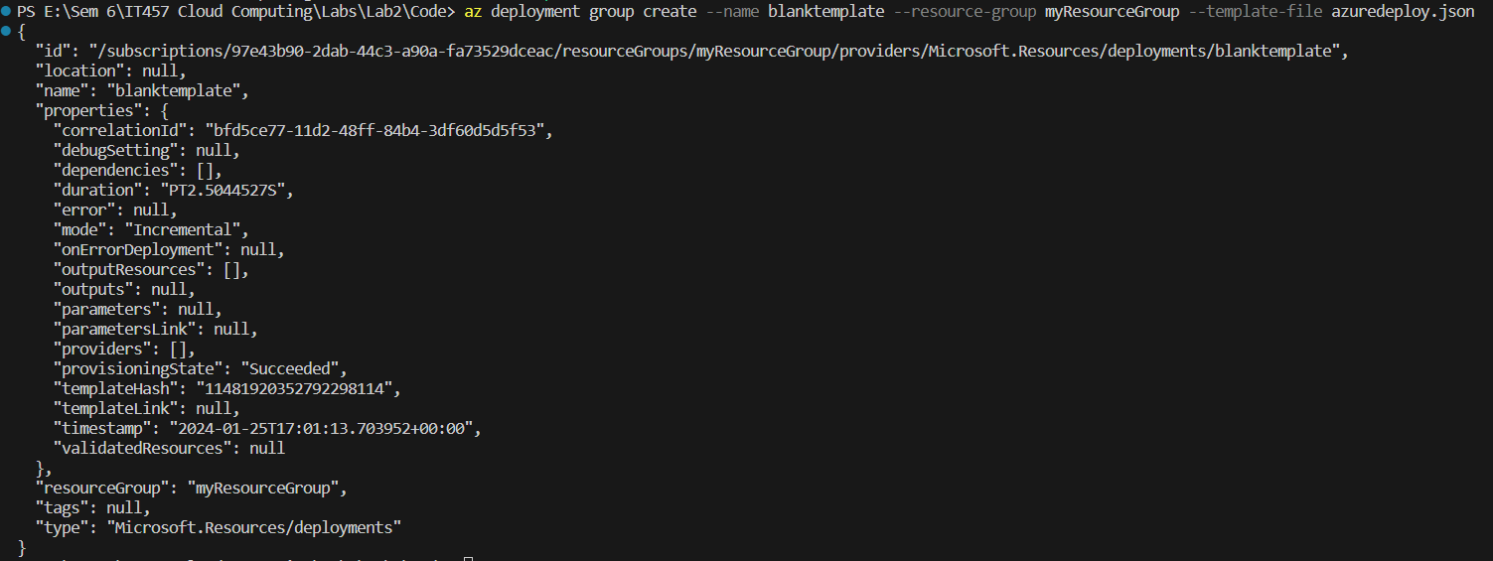

Result:

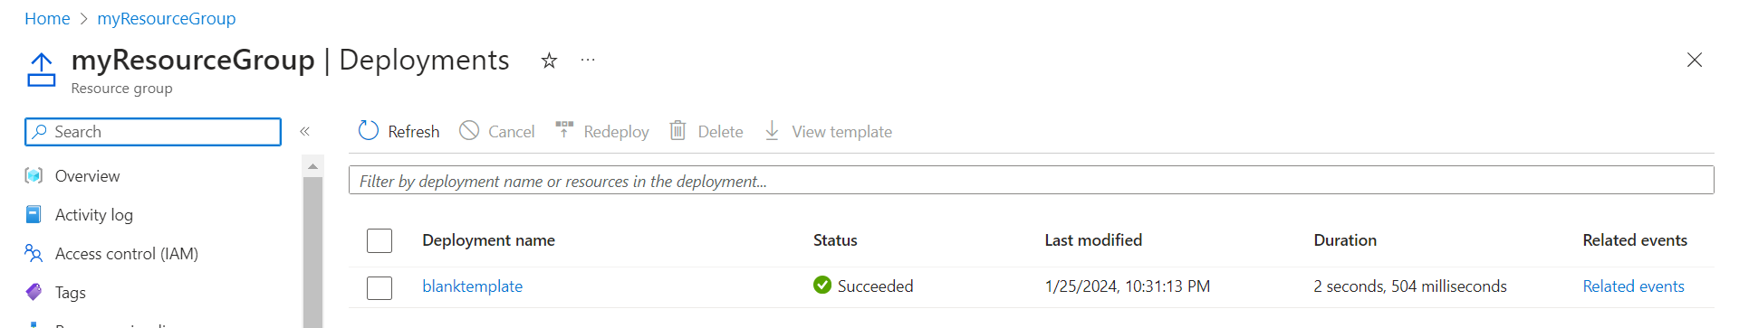

b. Adding resource

JSON:

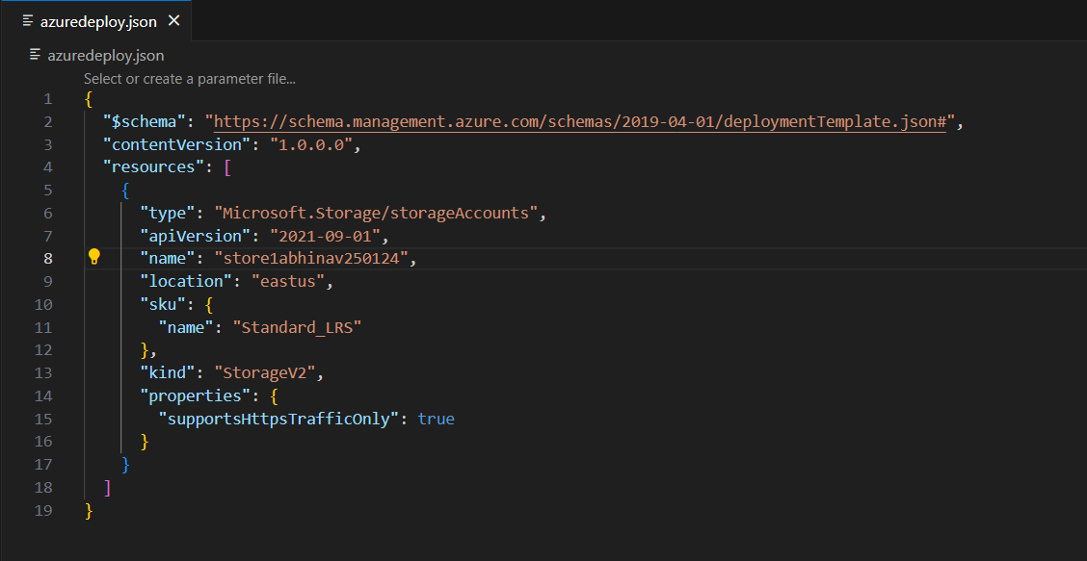

Deployment:

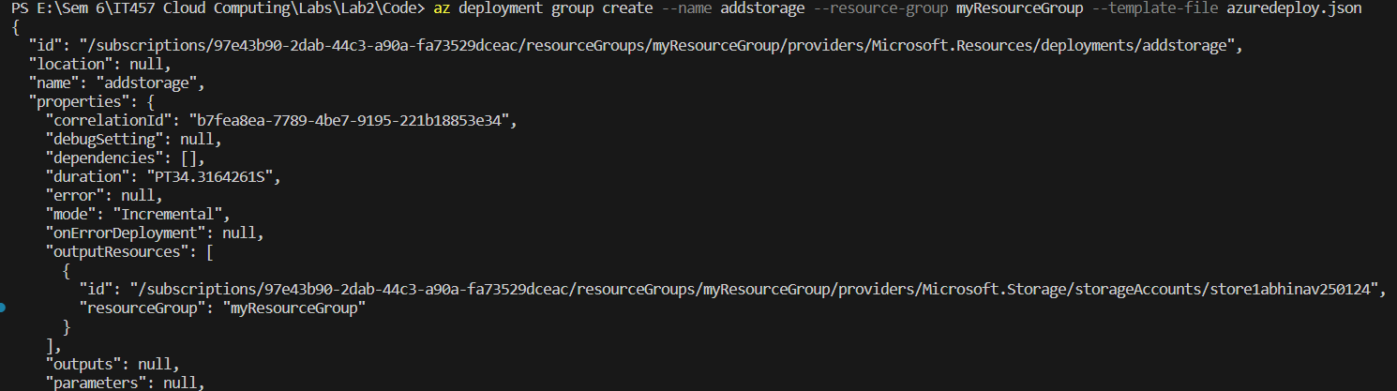

Result:

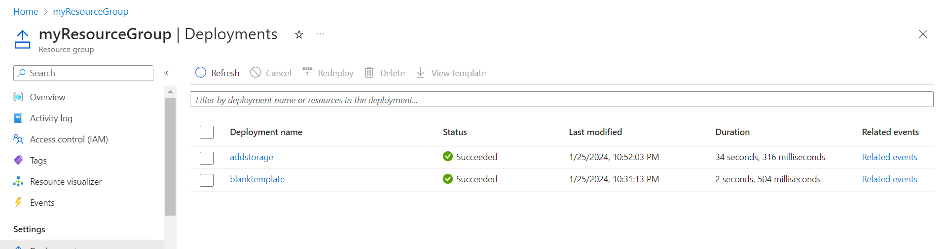

c. Adding parameters

JSON:

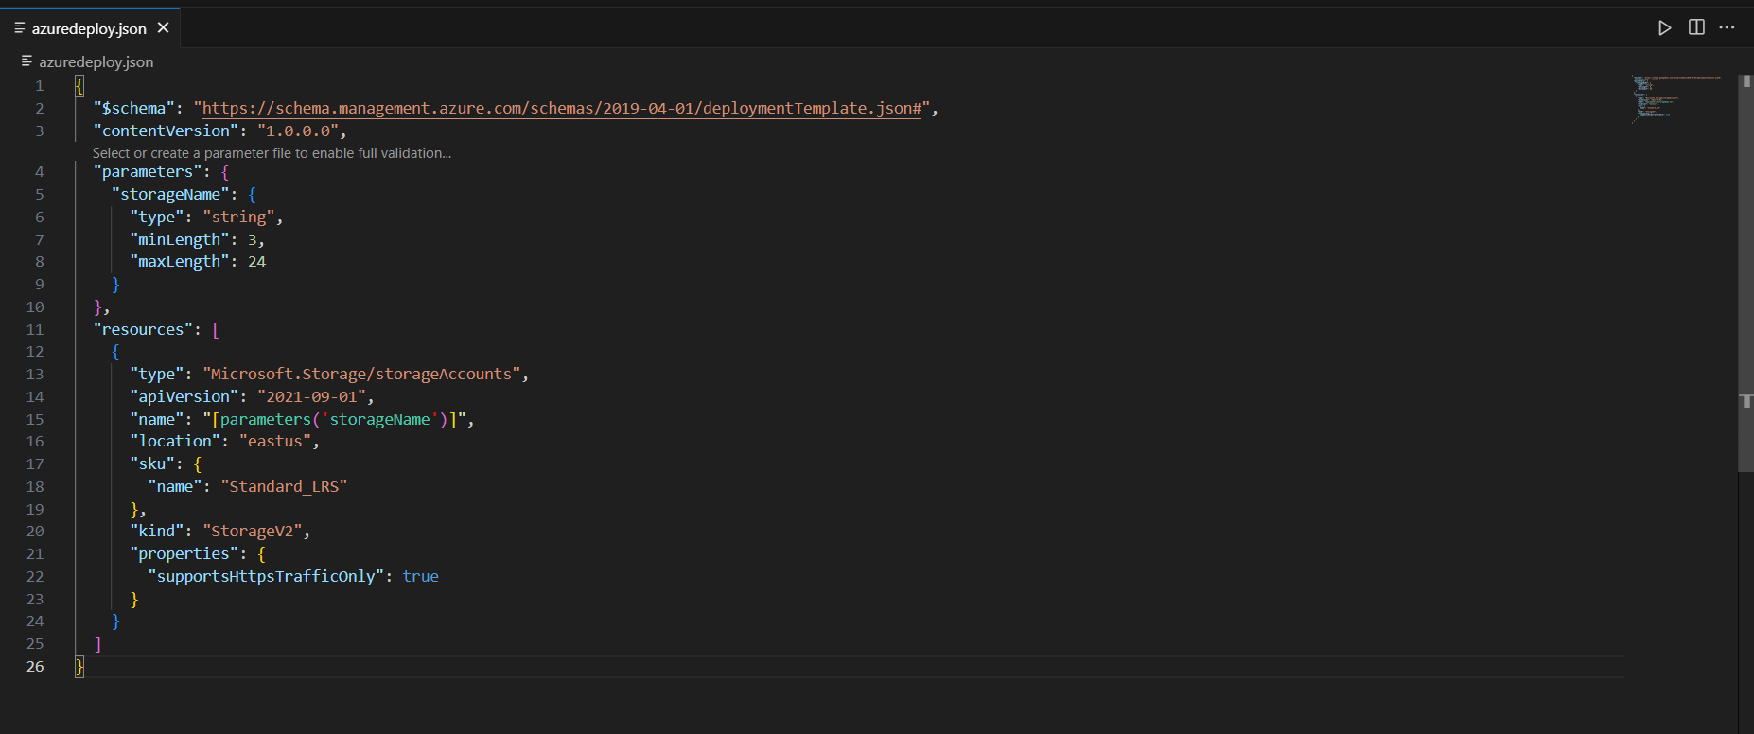

Deployment:

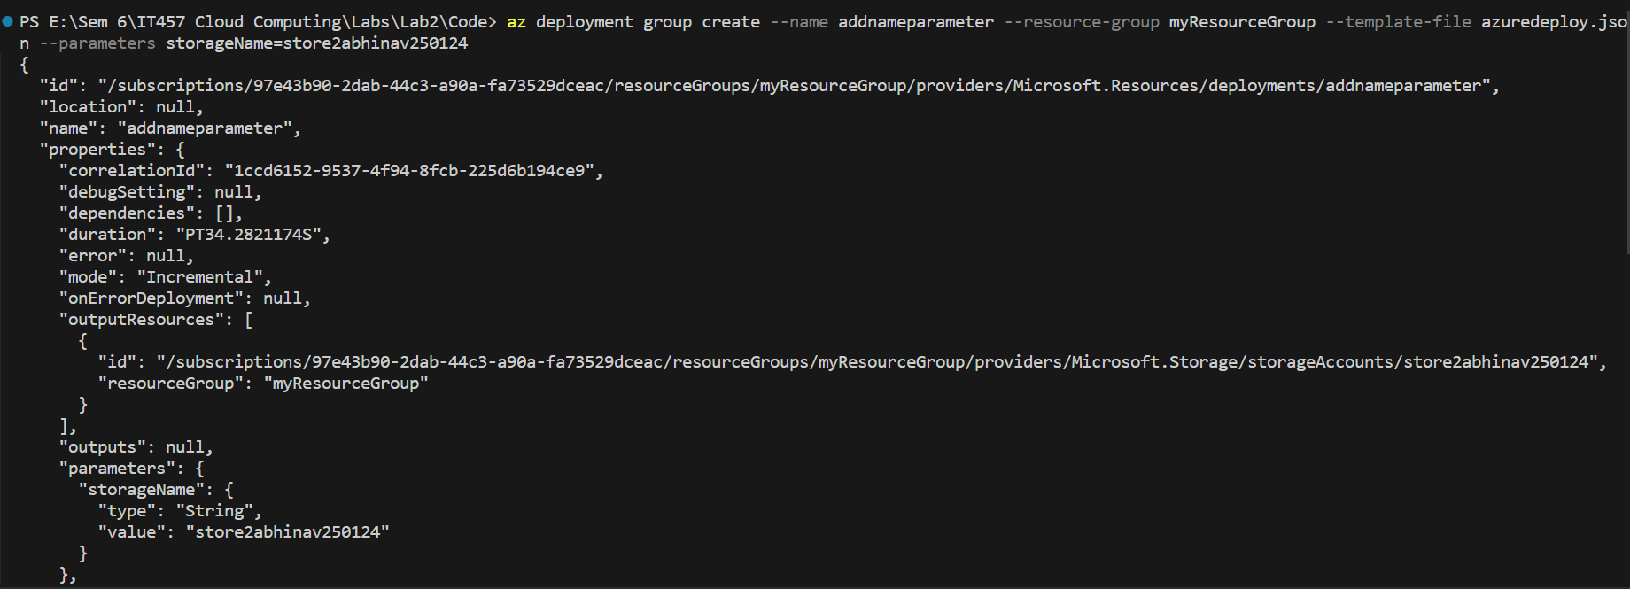

Result:

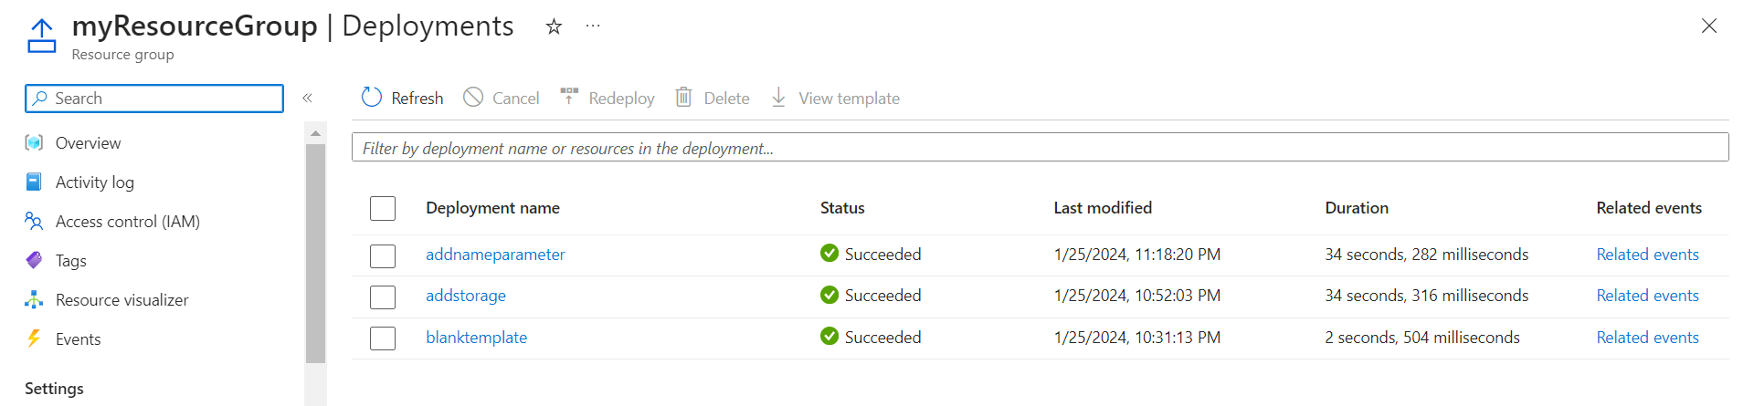

Redeploying with SKU parameters: -

JSON:

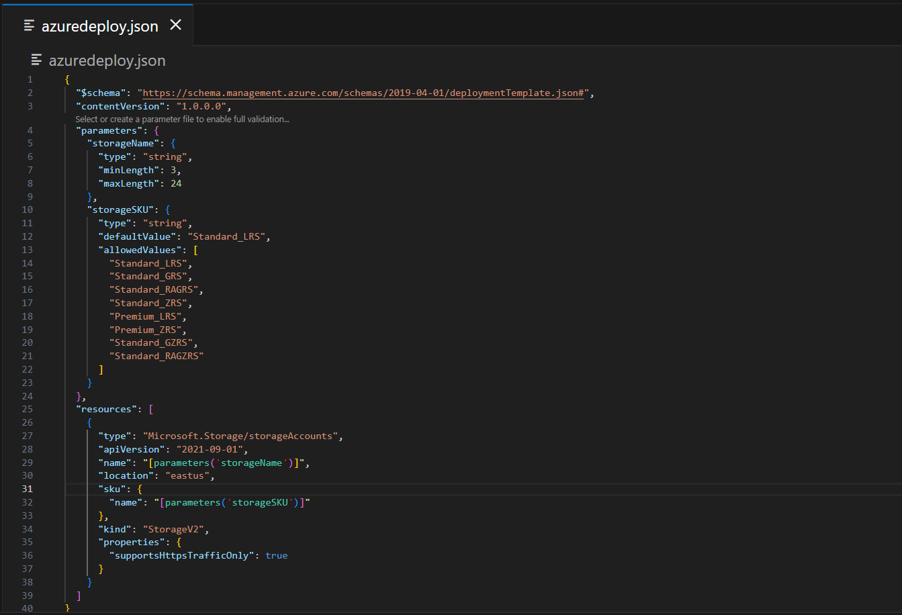

Deployment:

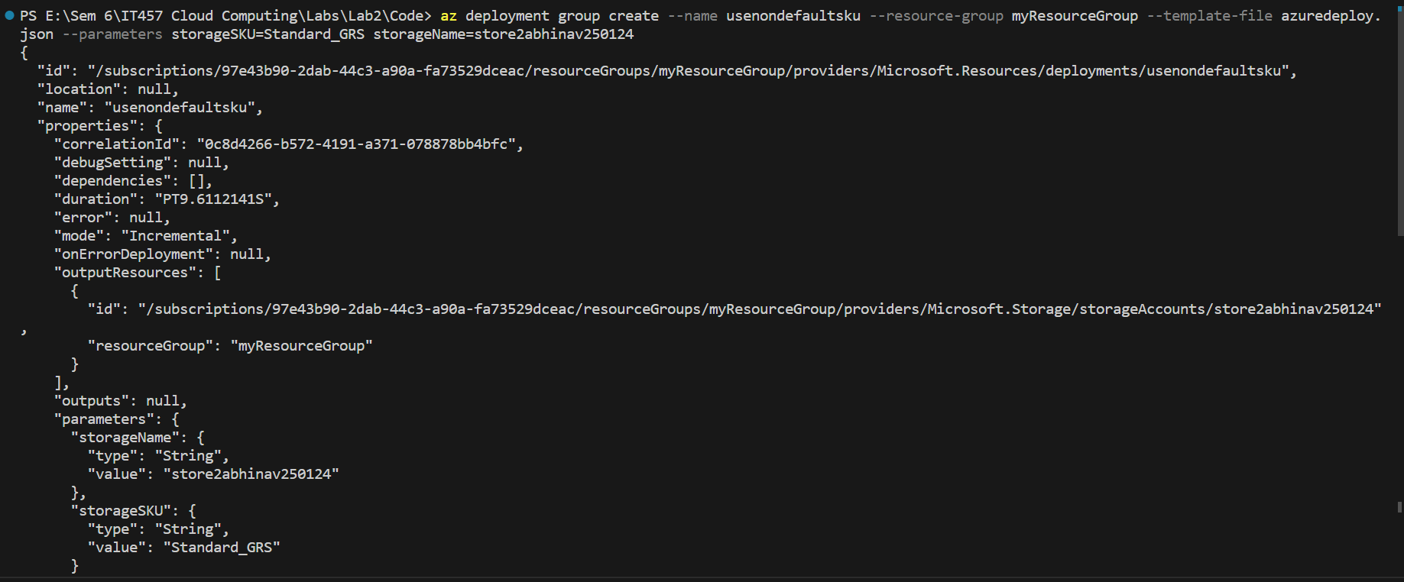

Result:

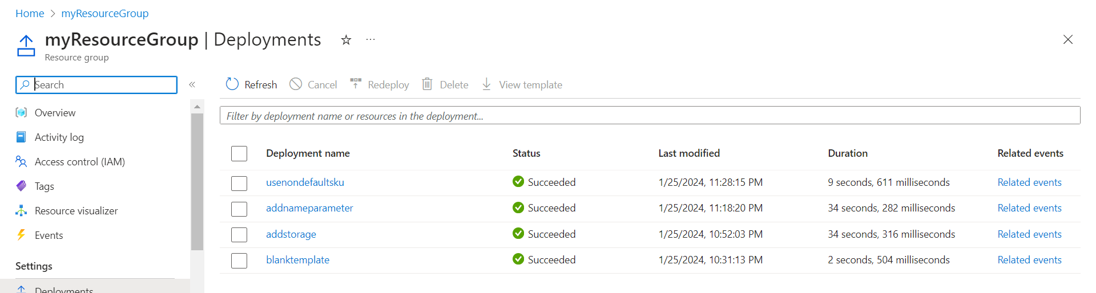

d. Adding template functions

Deployment:

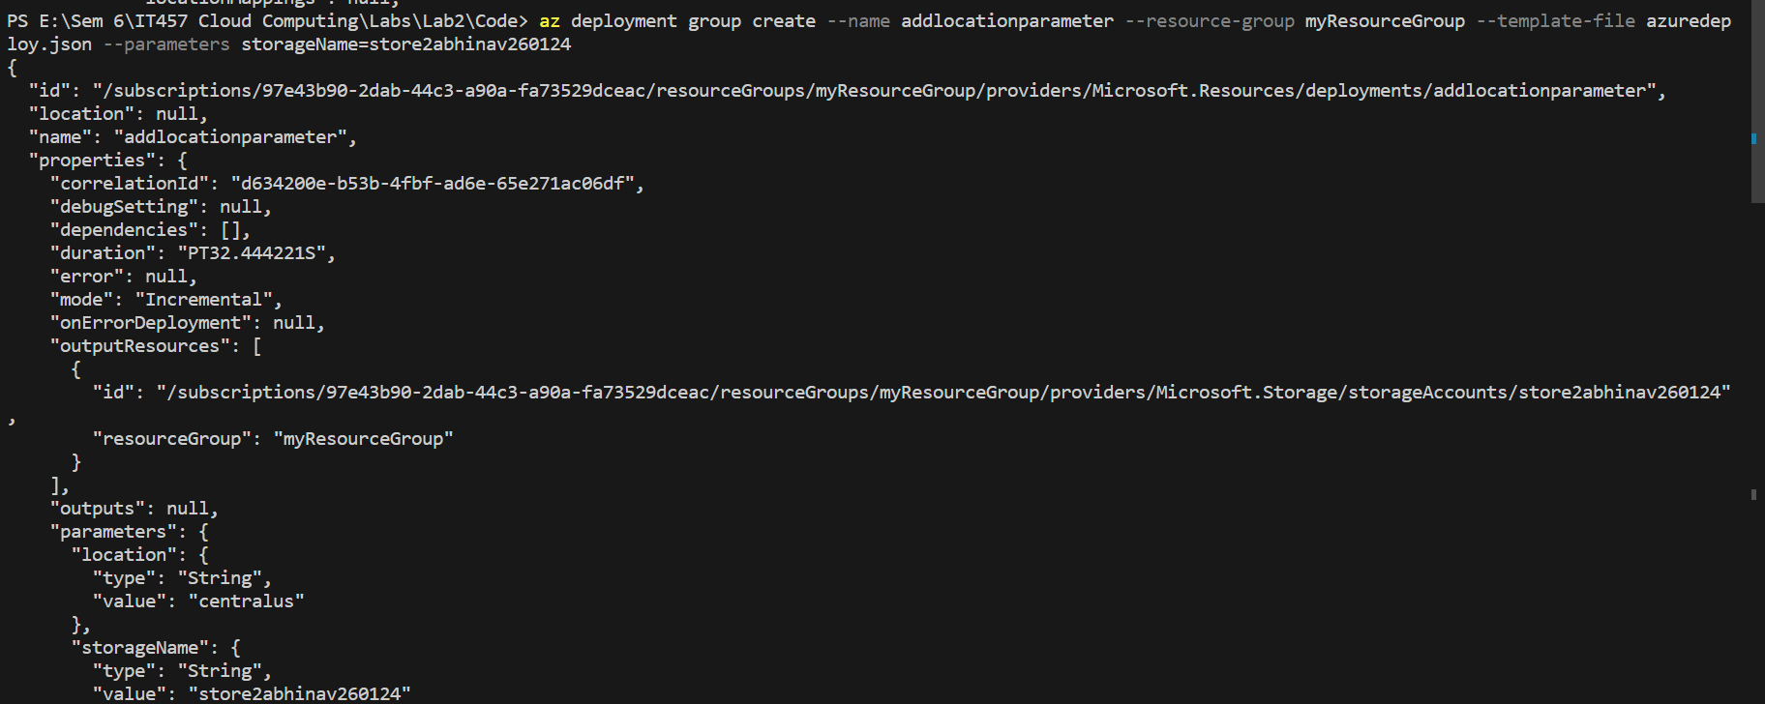

Result:

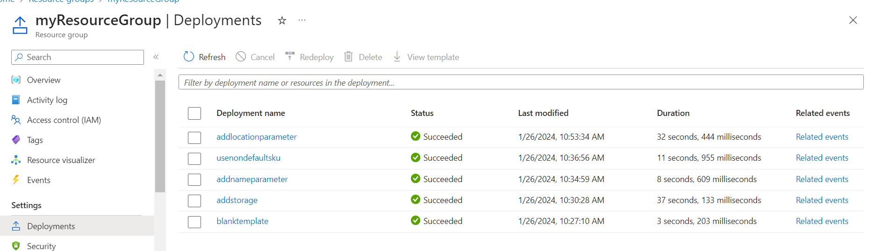

Resource group and storage account location is in Central US.

e. Adding variables

Deployment:

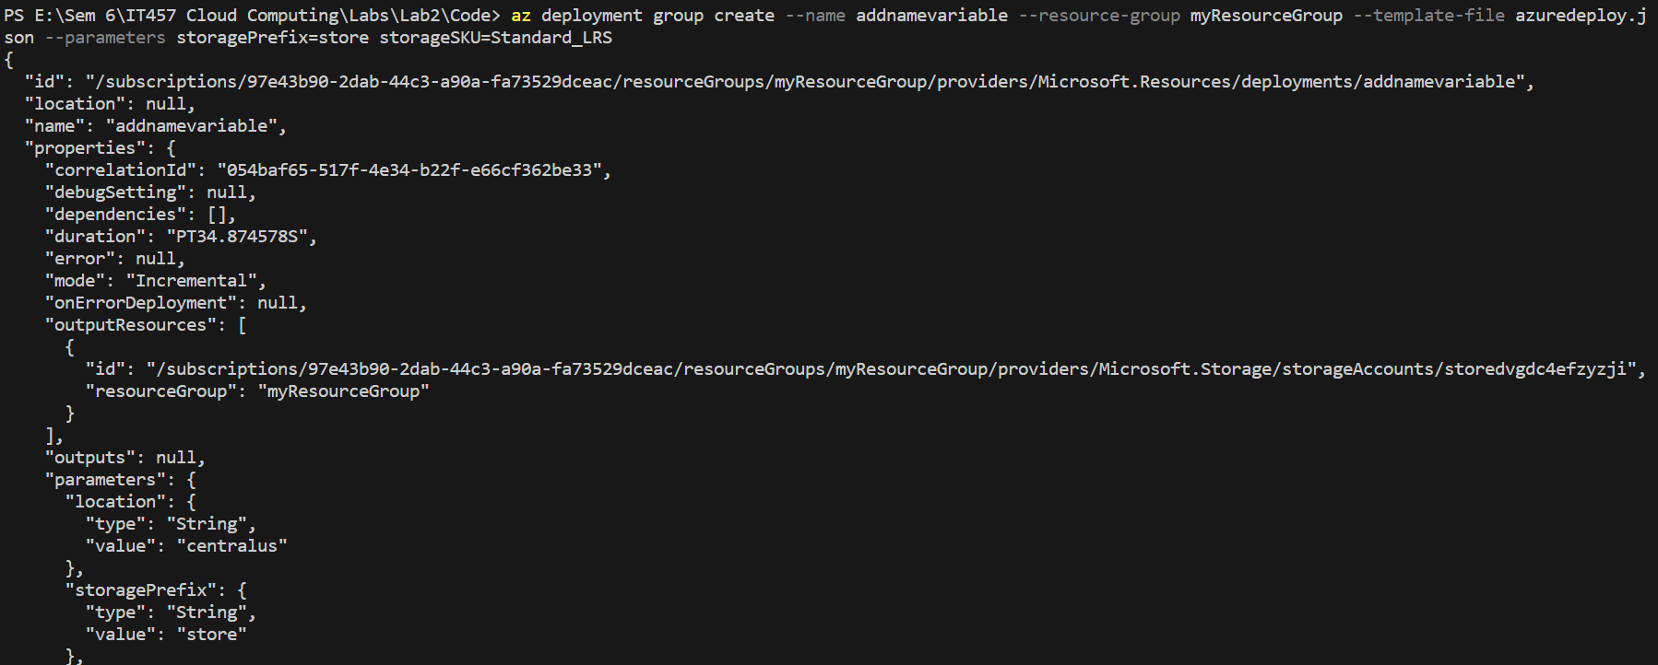

Result:

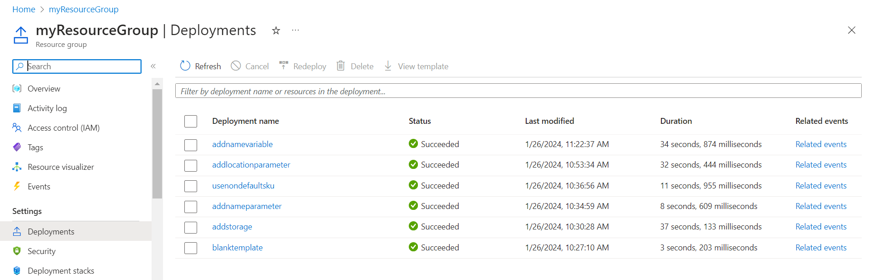

f. Adding outputs

Deployment:

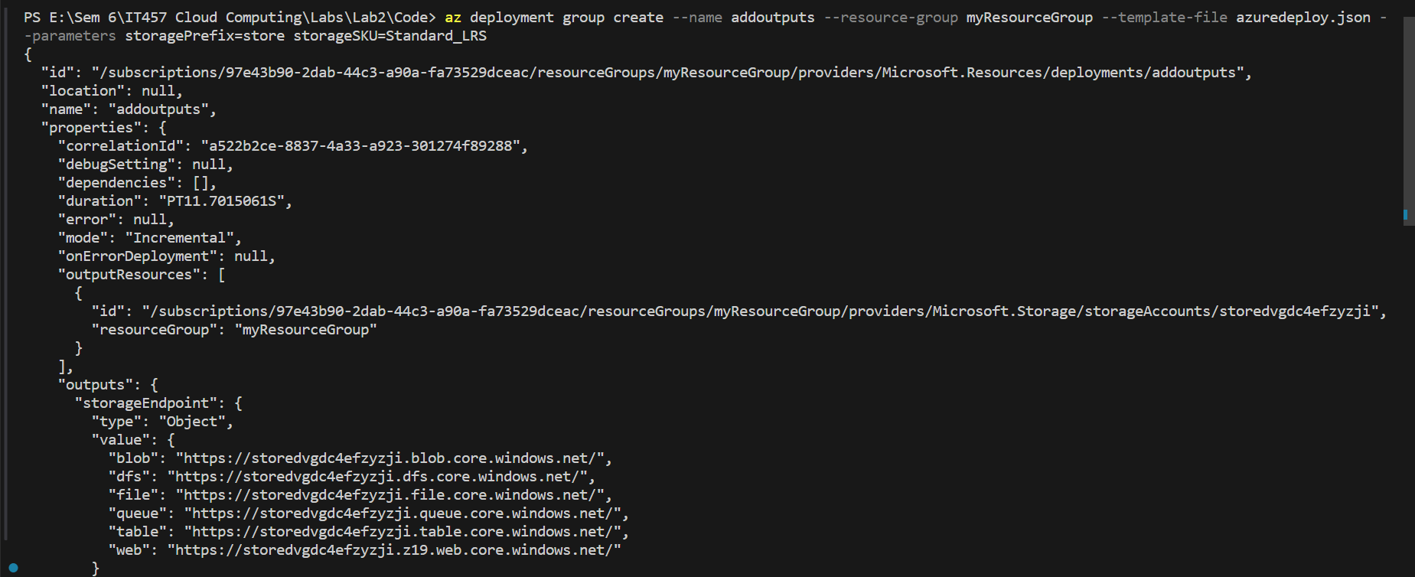

Result:

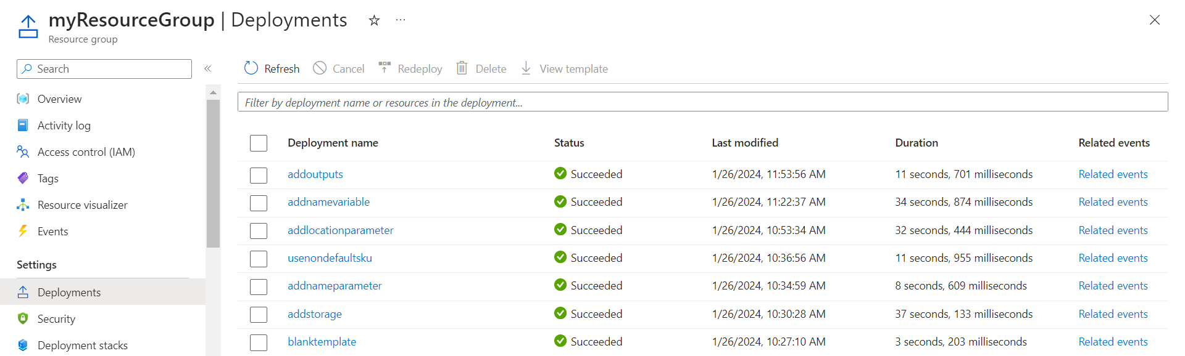

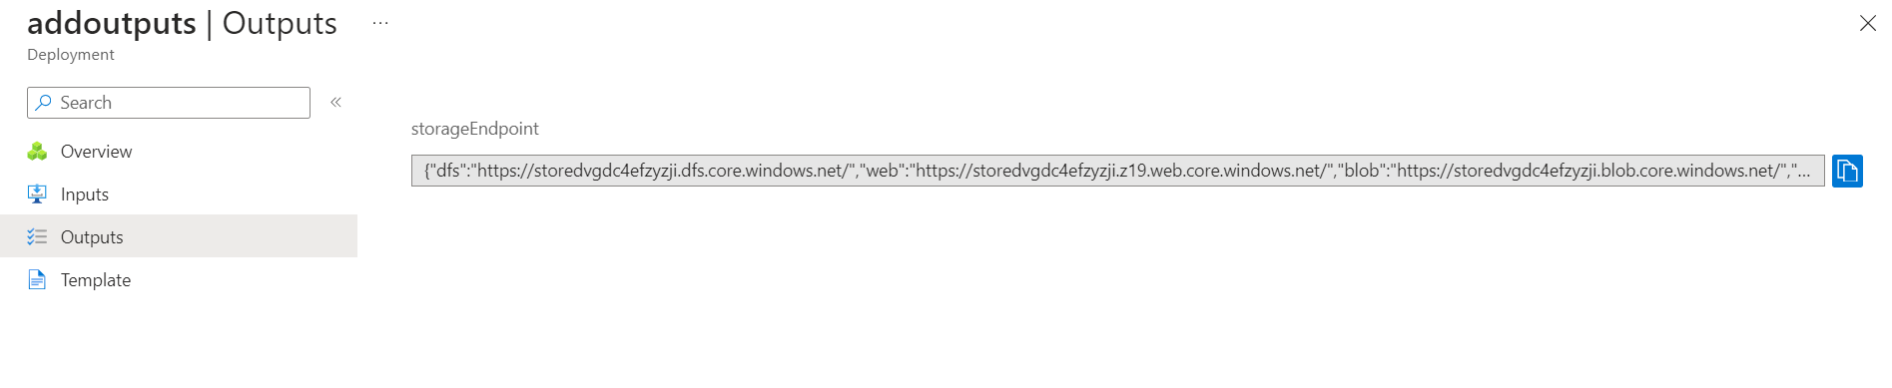

g. Using exported template

Exporting template:

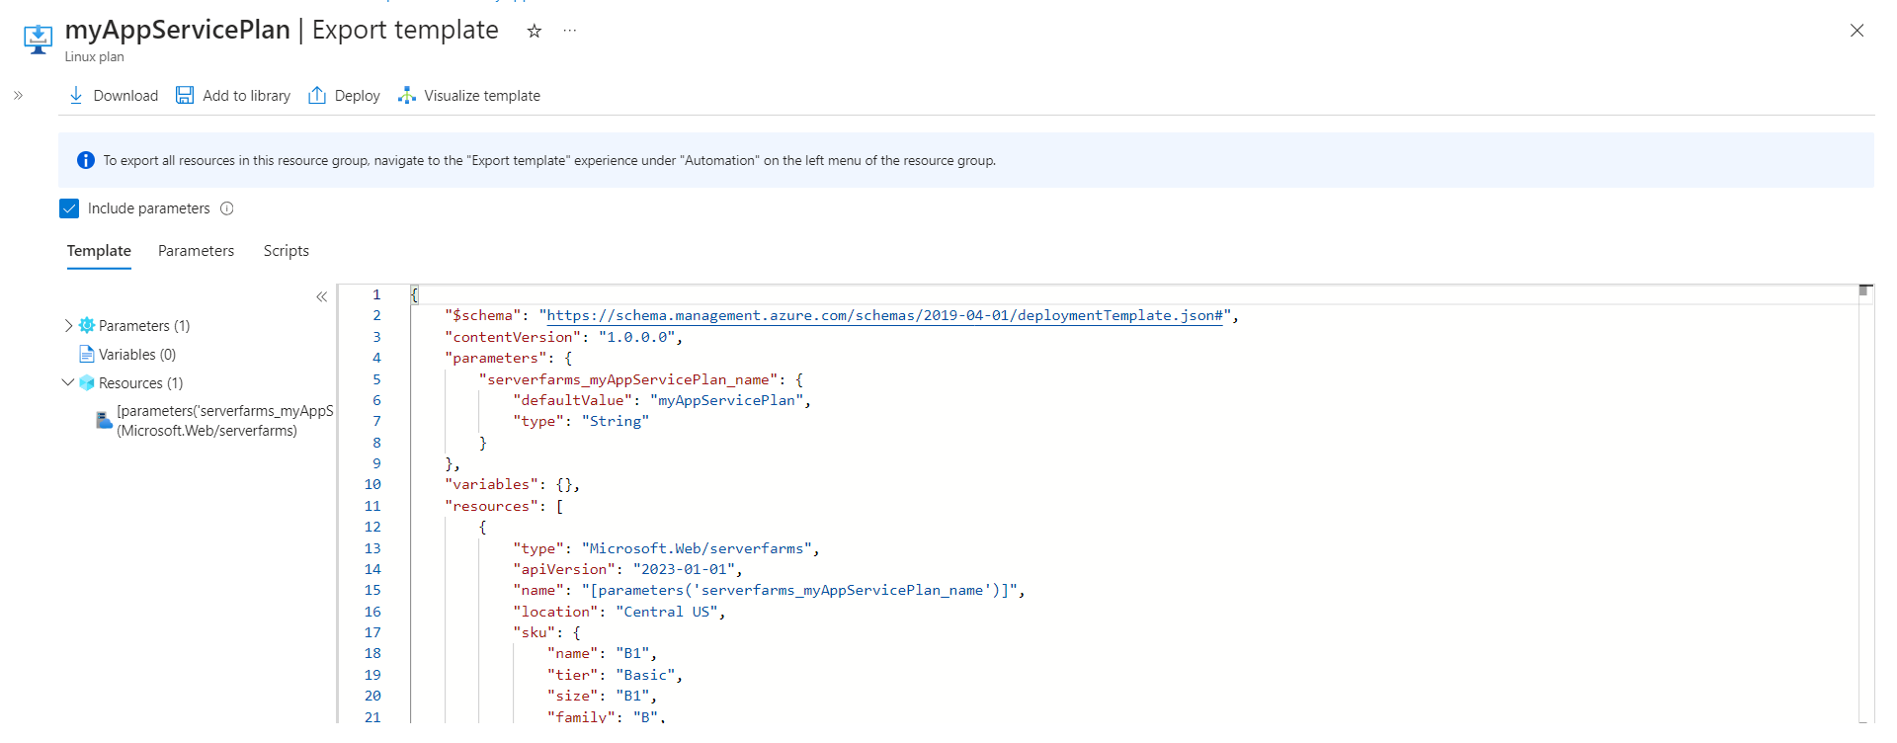

Deployment of revised exported template:

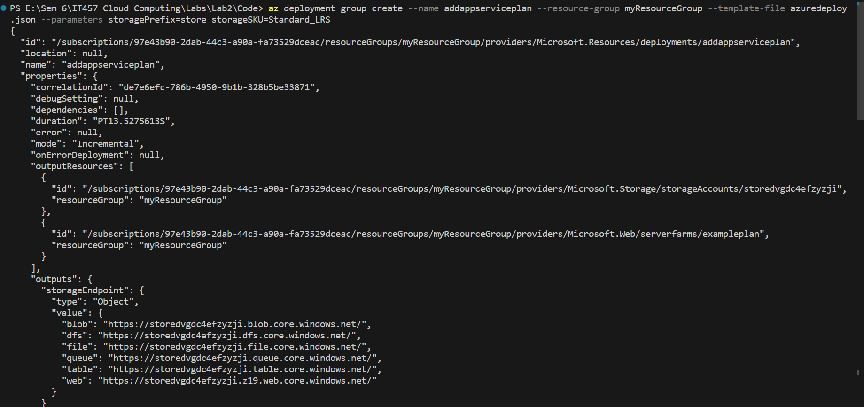

Result:

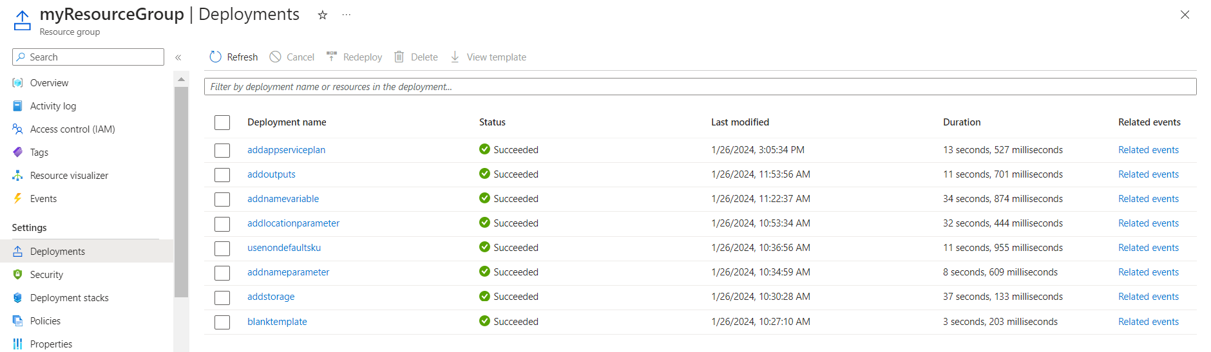



h. Using QuickStart template

QuickStart template:

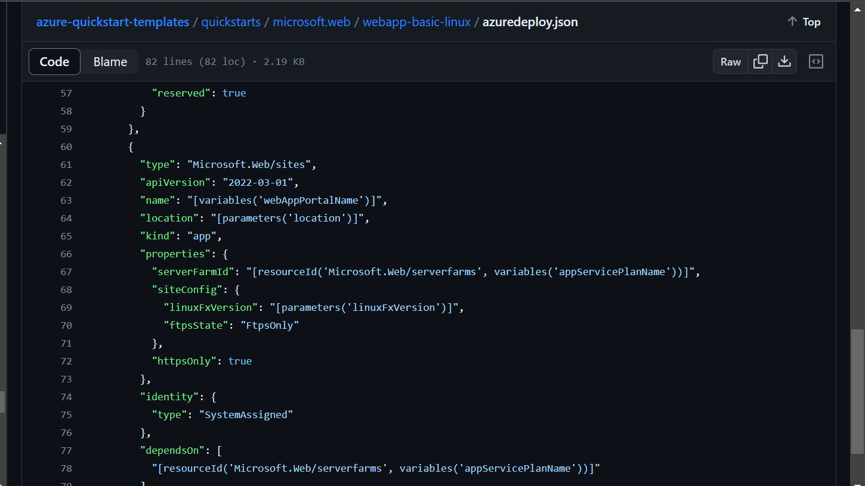

Deployment:

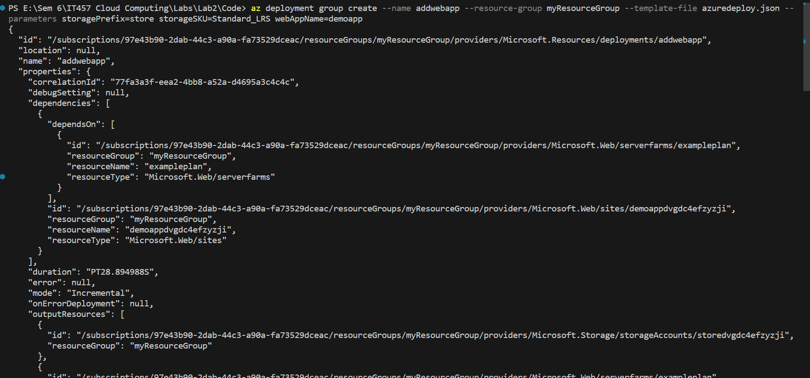

Result:

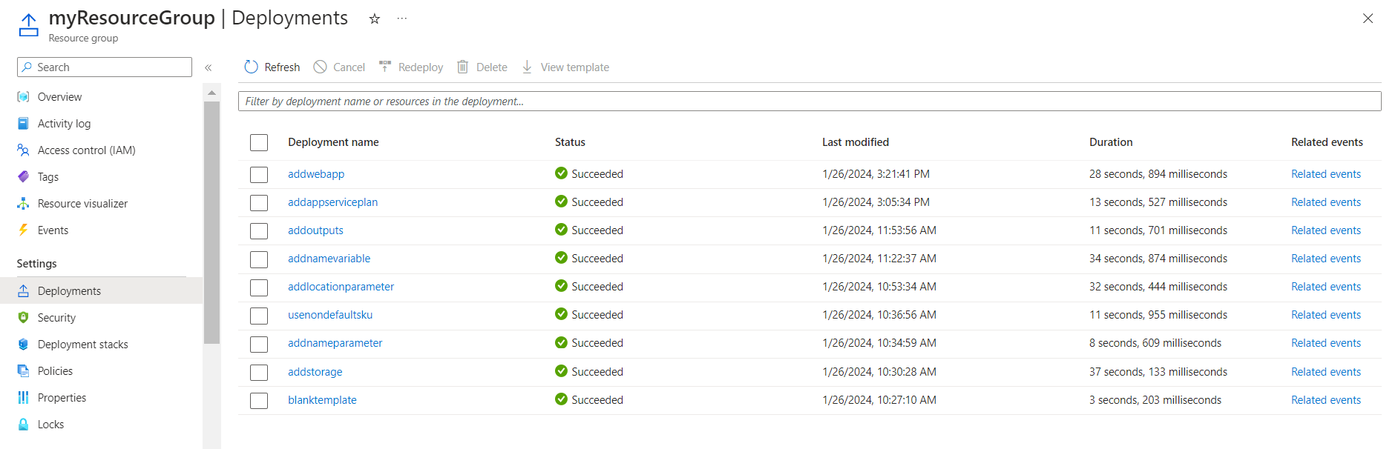



i. Adding Tags

Deployment:

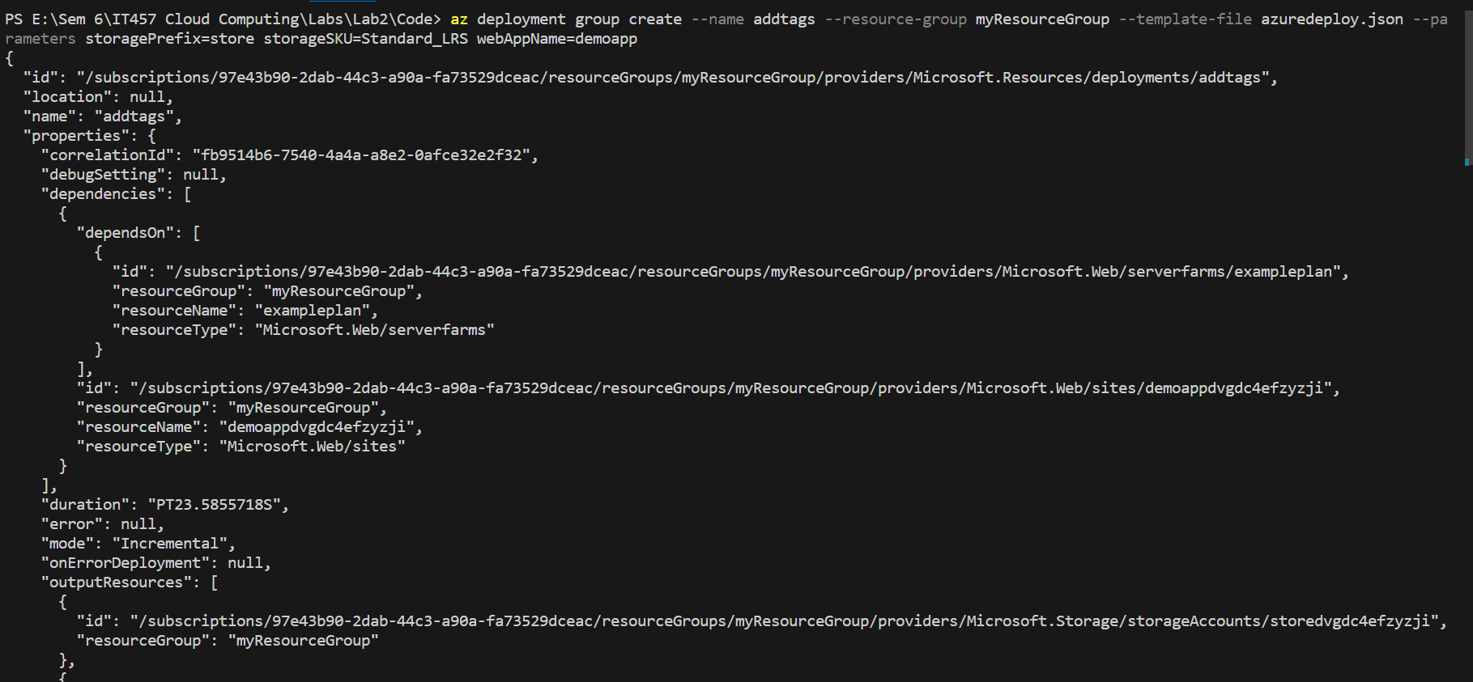

Result:

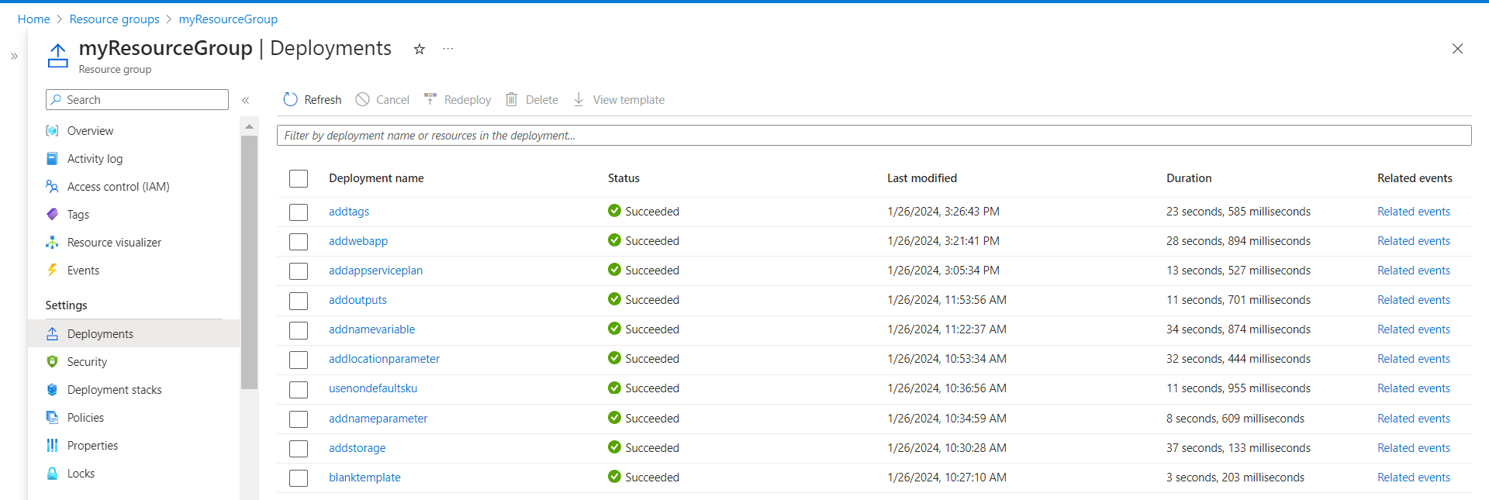

j. Using parameter files

Parameter files:

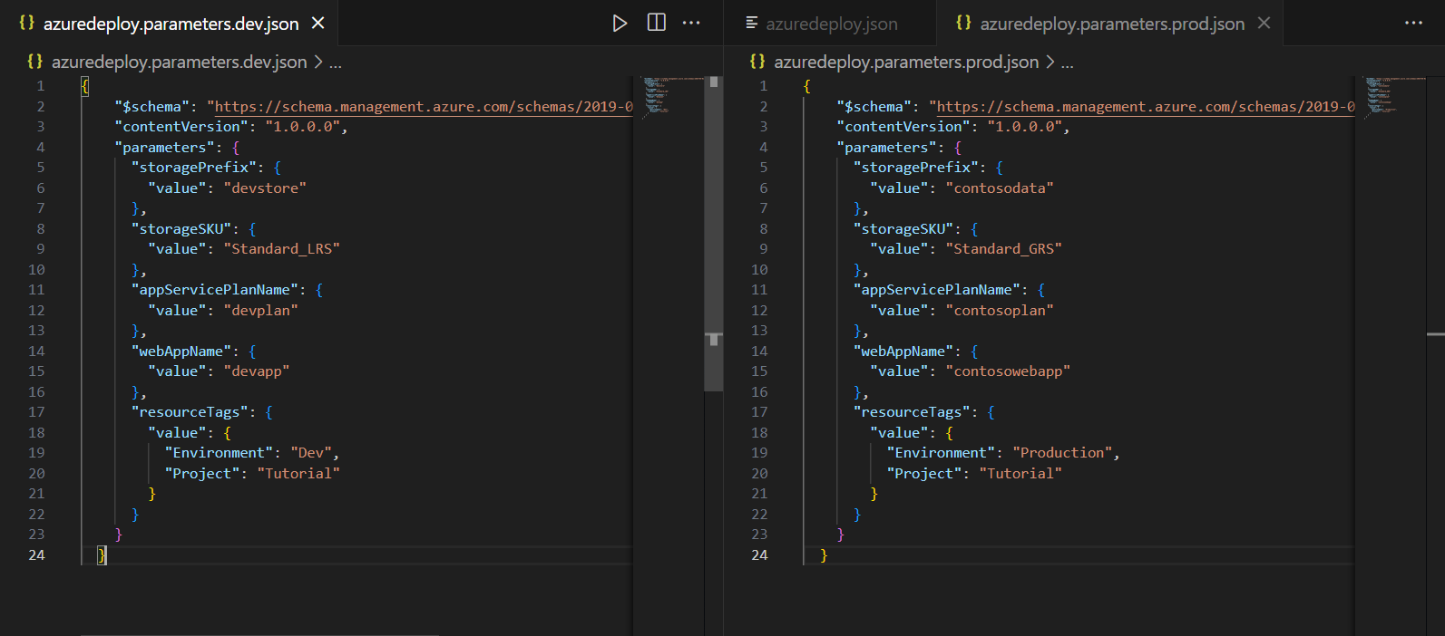



Deployment:

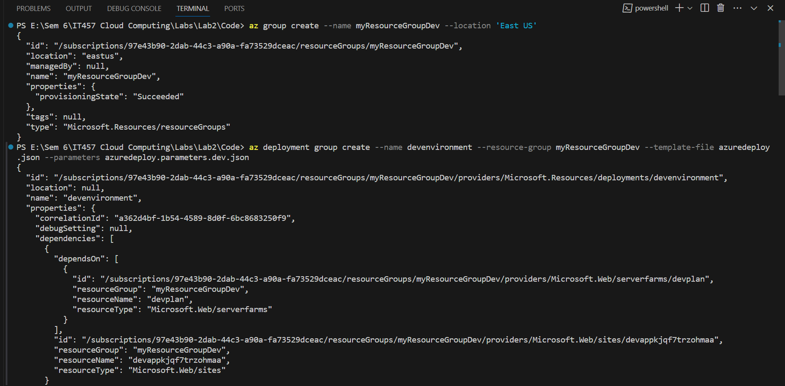

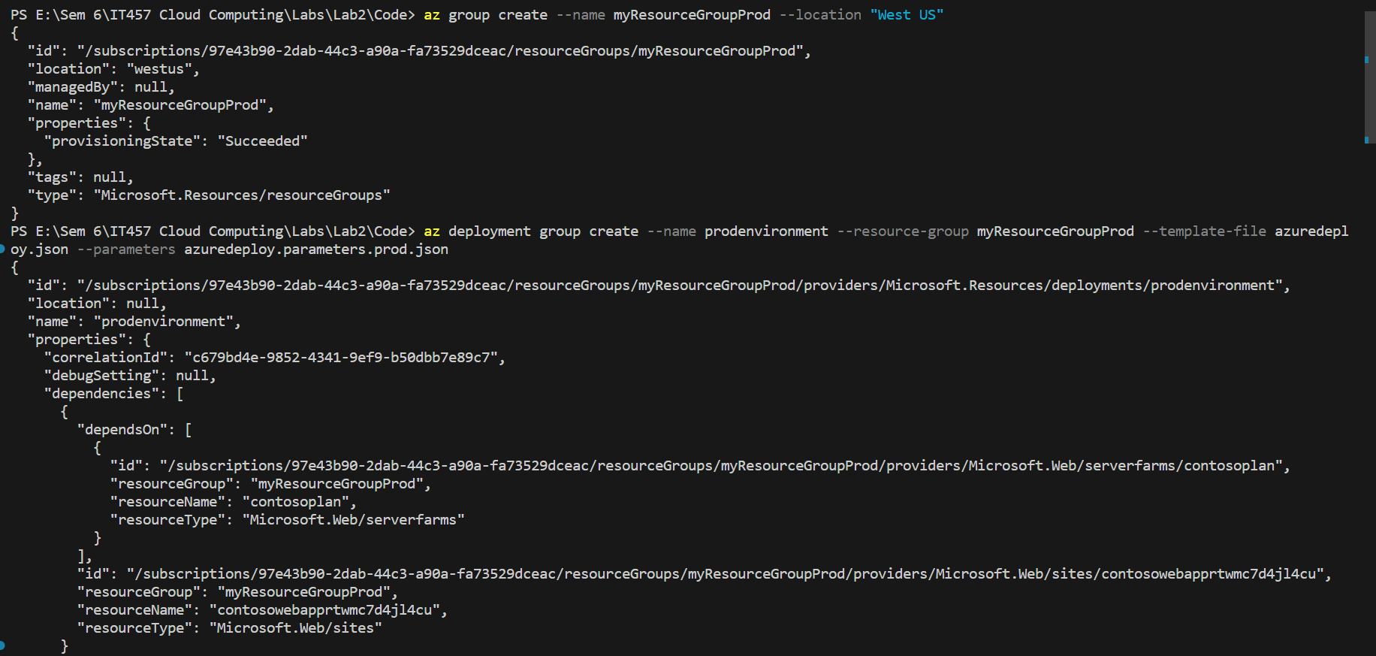

Result:

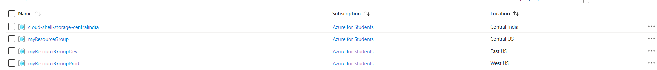

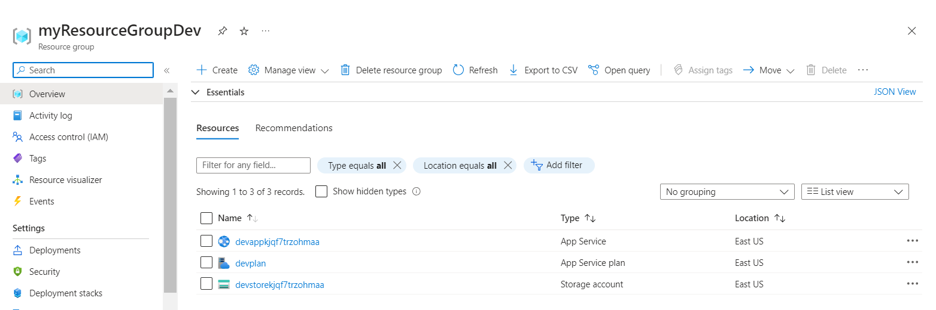

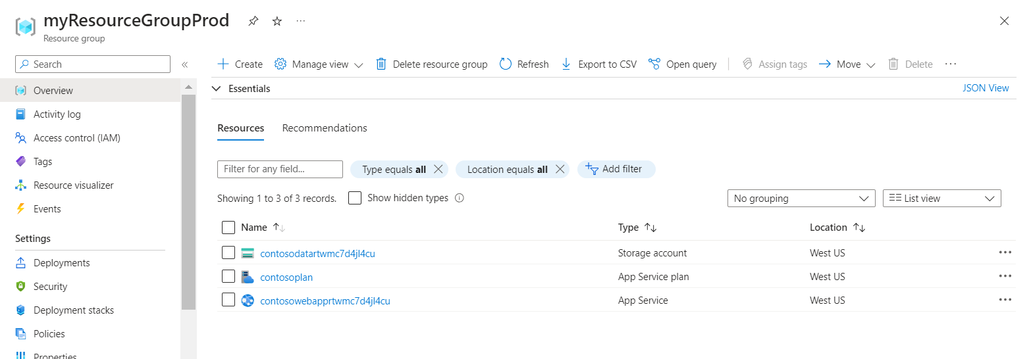

3. N-tier architecture: -

Deployment:

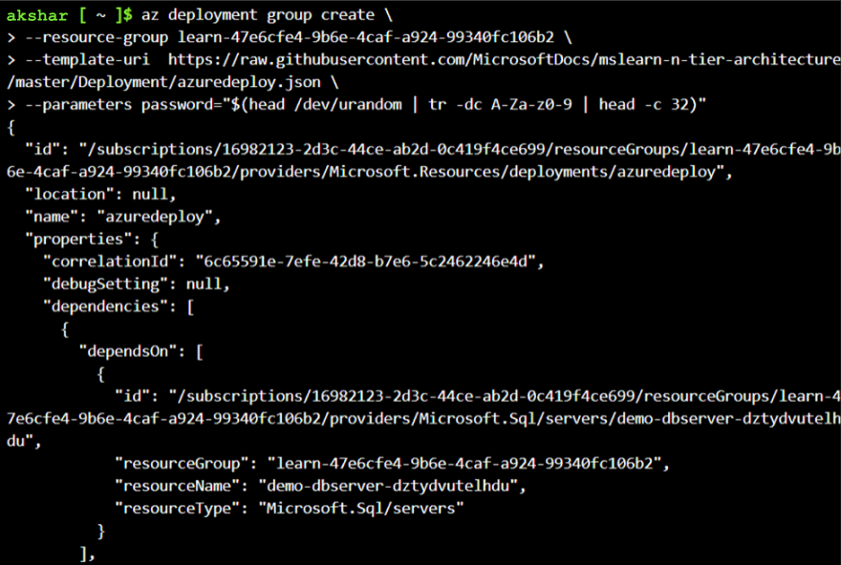

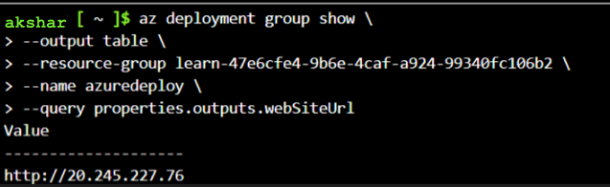

Result:

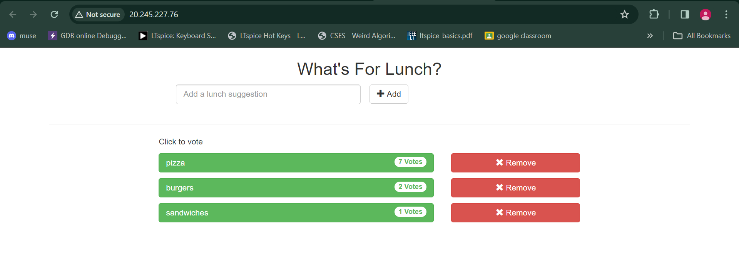

1. Presentation Tier

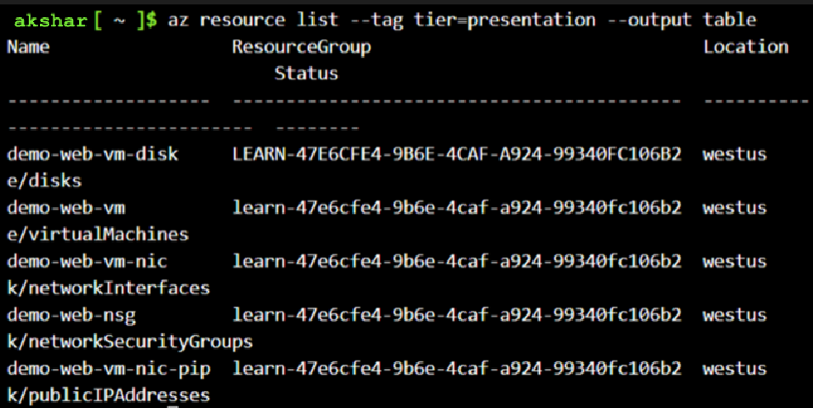

1. Application Tier

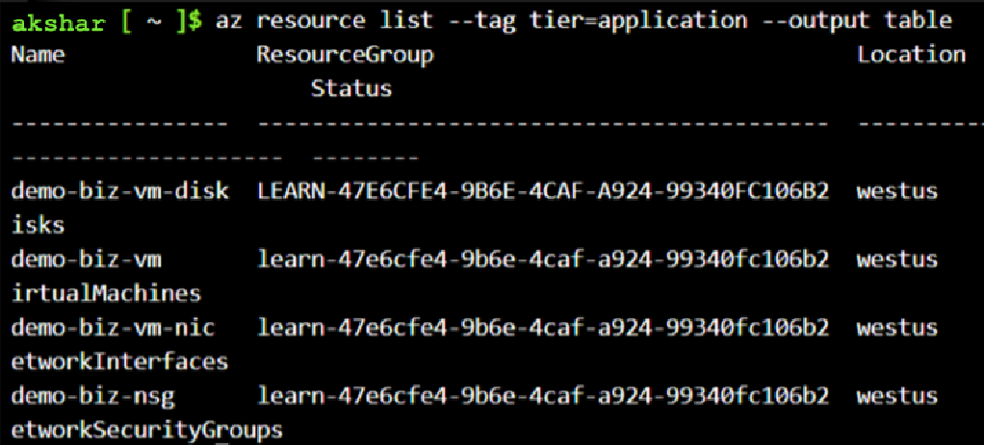

1. Data Tier

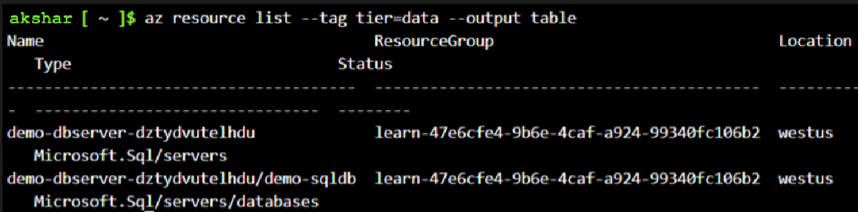

4. Application Gateway Tutorial: -

Resources created:

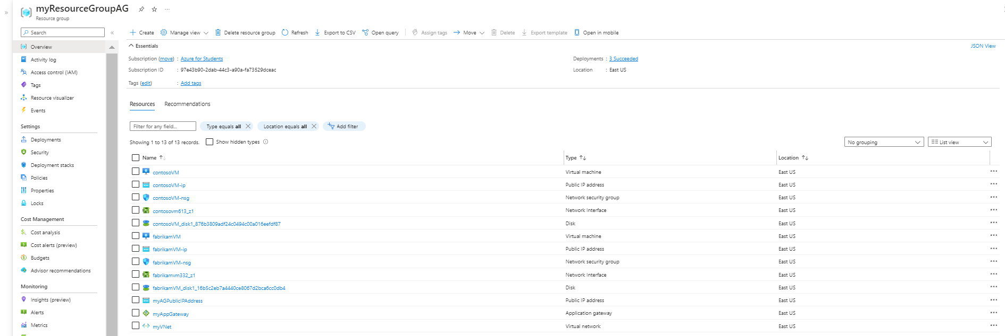

IIS installation:

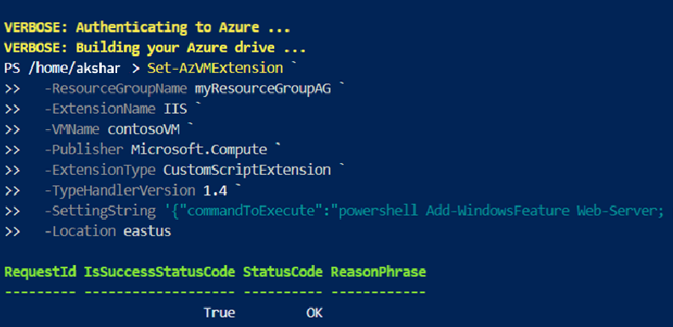

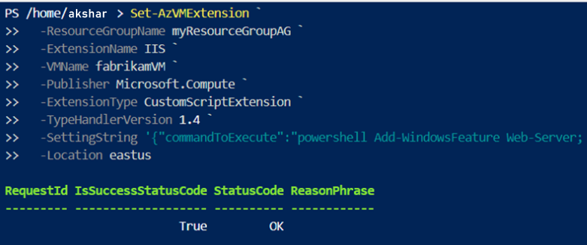

IP Address: 20.127.93.242

Result:

